Lab # 8
Banker’s Algorithm

Deadlock
Banker's Algorithm is a deadlock avoidance algorithm that checks for safe or unsafe state of a System after allocating resources to a process.

When a new process enters into system ,it must declare maximum no. of instances of each resource that it may need.After requesting operating system run banker's algorithm to check whether after allocating requested resources,system goes into deadlock state or not. If yes then it will deny the request of resources made by process else it allocate resources to that process.

No. of requested resources (instances of each resource) may not exceed no. of available resources in operating system and when a process completes it must release all the requested and already allocated resources.

For implementing Banker's algorithm we should have pre-knowledge about three things:
How many instance of each resource a process could request. (Max)
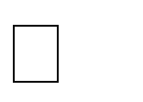

How many instance of each resource is already allocated to that process(Allocated) How many instance of each resource is already available(Available).
We can calculate need of each process from above information: Need=Max - Allocated.
If need<=available then request will be accepted otherwise it is denied and it will check for next process in waiting queue.(See Life Cycle Of a Process)

Safe or Unsafe State: A system is in Safe state if its all process finish its execution or if any process is unable to aquire its all requested resources then system will be in Unsafe state.

#include <iostream>
using namespace std;

int main()
{
// P0, P1, P2, P3, P4 are the Process names here

int n, m, i, j, k;
n = 5; // Number of processes m = 3; // Number of resources
int alloc[5][3] = { { 0, 1, 0 }, // P0 // Allocation Matrix
{ 2, 0, 0 }, // P1
{ 3, 0, 2 }, // P2
{ 2, 1, 1 }, // P3
{ 0, 0, 2 } }; //P4

int max[5][3] = { { 7, 5, 3 }, // P0 // MAX Matrix
{ 3, 2, 2 }, // P1
{ 9, 0, 2 }, // P2
{ 2, 2, 2 }, // P3
{ 4, 3, 3 } }; // P4

int avail[3] = { 3, 3, 2 }; // Available Resources
int f[n], ans[n], ind = 0;
for (k = 0; k < n; k++)
{
f[k] = 0;
}
int need[n][m];
for (i = 0; i < n; i++)
{
for (j = 0; j < m; j++)
need[i][j] = max[i][j] - alloc[i][j];
}
int y = 0;
for (k = 0; k < 5; k++)
{
for (i = 0; i < n; i++)
{
if (f[i] == 0)
{
int flag = 0;
for (j = 0; j < m; j++)
{
if (need[i][j] > avail[j])
{
flag = 1;
break;
}
}
if (flag == 0)
{
ans[ind++] = i;
for (y = 0; y < m; y++)
{
avail[y] += alloc[i][y];
f[i] = 1;
}
}
}
}
}
cout << "Following is the SAFE Sequence" << endl;
for (i = 0; i < n - 1; i++)
{
cout << " P" << ans[i] << " ->";
cout << " P" << ans[n - 1] <<endl;
return (0);
}

I. Output:
Following is the SAFE Sequence
P1 -> P3 -> P4 -> P0 -> P2

II. Deadlock Real life Scenario
A simple real-time example of deadlock is that suppose there are two friends John and Jerry that are drawing a diagram. During drawing, John needs an eraser, so he will use (lock) the eraser.
Meanwhile, Jerry needs ruler, so he will use (lock) the ruler. Currently, eraser and ruler are not occupied by any of the friends. Now John needs a ruler to continue his drawing. But Jerry will not give it because he is using it currently.
Later on, Jerry needs an eraser but John will not give it as his drawing is not completed because of waiting for the ruler. Thus, none of the friends will release stationary objects and both will wait infinitely for each other to release stationary. This situation is called deadlock in Java.
Similarly, assume that there are two threads t1 and t2. Both threads are running concurrently (simultaneously). During execution, thread t1 is waiting for data that is locked by thread t2 and t2 is waiting for data that is locked by thread t1.
In this case, none of the threads will unlock the lock because of not completing their execution process. This situation is called deadlock.
When thread deadlock occurs in a program, the further execution of program will stop. Therefore, thread deadlock is a drawback in a program. We should take care to avoid deadlock while coding. 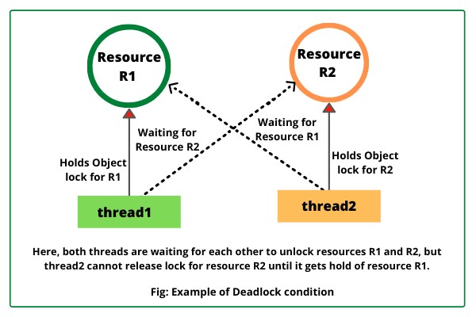
public class X
{
void display1(X obj2)
{
System.out.println("Thread1 waiting for thread2 to release lock");
synchronized(obj2)
{
System.out.println("Deadlock occurred");
}
}
void display2(X obj1)
{
System.out.println("Thread2 waiting for thread1 to release lock");
synchronized(obj1)
{
System.out.println("Deadlock occurred");
}
}
}
public class Thread1 extends Thread
{
X obj1, obj2;
Thread1(X obj1, X obj2)
{
this.obj1 = obj1; this.obj2 = obj2;
}
public void run()
{
synchronized(obj1)
{
try
{
Thread.sleep(1000);
}
catch(InterruptedException ie)
{
System.out.println(ie);
}
obj2.display2(obj2);
}
}
}
public class Thread2 extends Thread
{
X obj1, obj2;
Thread2(X obj1, X obj2)
{
this.obj1 = obj1;
this.obj2 = obj2;
}
public void run()
{
synchronized(obj2)
{
try
{
Thread.sleep(1000);
}
catch(InterruptedException ie)
{
System.out.println(ie);
}
obj1.display1(obj1);
}
}
}

public class Deadlock { public static void main(String[] args)
{
X obj1 = new X();
X obj2 = new X();

Thread1 t1 = new Thread1(obj1, obj2);
Thread2 t2 = new Thread2(obj1, obj2);
t1.start(); t2.start();
}
}

Output:
Thread1 waiting for thread2 to release lock
Thread2 waiting for thread1 to release lock

